**TeamSnap Basics**

**Note:** These instructions are based on using the TeamSnap app. You can also access TeamSnap from your desktop computer and the basic instructions are the same but the layout will look different.

Once you are setup as the Team Administrator (TA) you will appear on the Roster as a Non-Player.

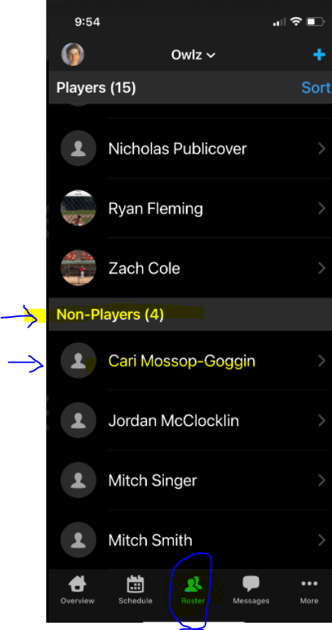

When you are in the app, at the top where the team name is there are drop box options. This will show you in Teamsnap as either the Manager – as I have highlighted now or as your child (the player).

When you are in manager function you have more options to do different tasks. 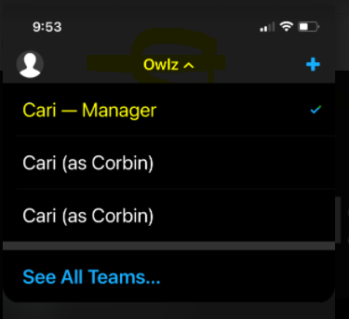

**Health Checks:**

Within the schedule, the MY HEALTH CHECK is where the players and coaches complete the form on their health checks. The form is availabe 12 hours BEFORE the start of the game/practice/event.

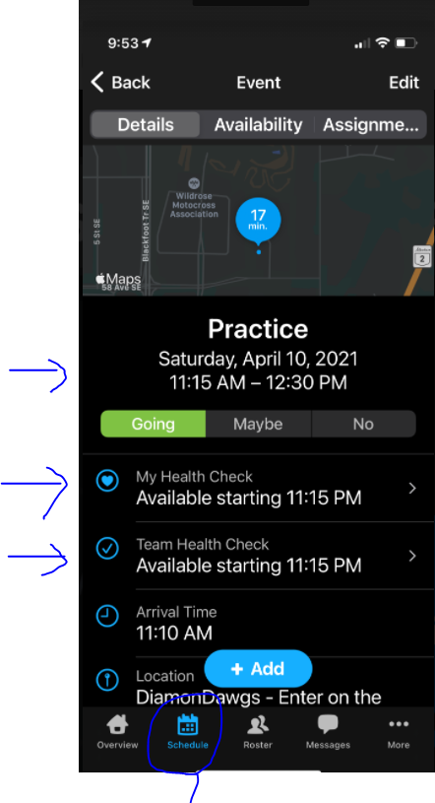

**One hour before the practice/game/event** – we are asking you to check the team availability for the event – you can check the availability by clicking the link at the top of the scheduled event. This will tell you all the players and coaches that have updated their availability.

Once you know who is going to be attending, go to the Team Health Check section and see who has completed the Health Check Forms. You should have forms for all of those that have stated they were a “yes” for attending – including Coaches. As a manager you will appear as one of the incomplete health checks – you do not have to complete a form. Send a chat message from TeamSnap to the team with a reminder to complete the form and then send a separate chat to the coach with on who hasn’t completed the forms yet. The rest is up to the Coach to ensure players complete the form before playing or practicing.

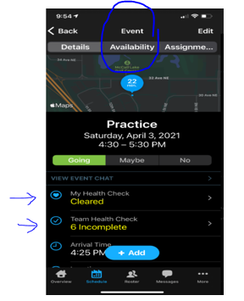

**Sending a chat within the TeamSnap App**

At the bottom of the app, to to Messages and you will have options for Chat/Posts/Emails/Alerts

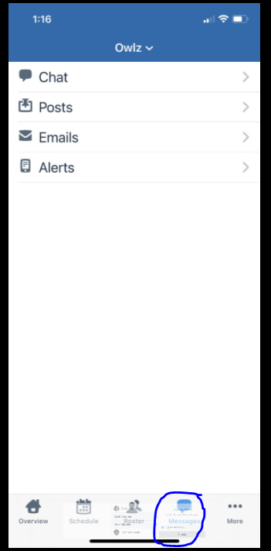

Once you click on Chat – then you can lick on the + in the upper right hand corner.

You can click on the players and then check all the contacts you want to invite to the chat. Then click “next”. You then have the option to create a name for the Chat group

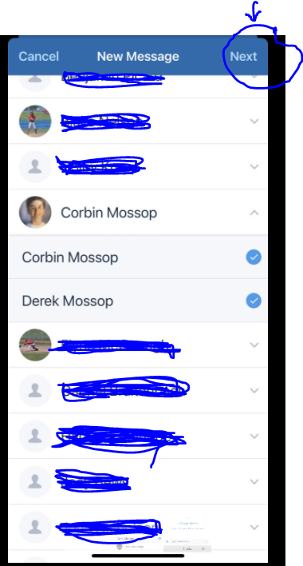

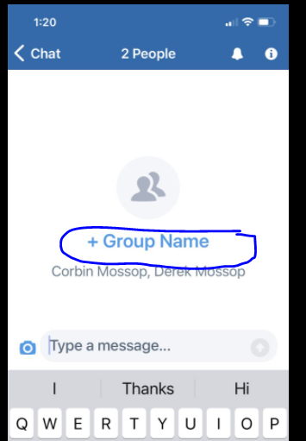

**Creating Practices / Games / Events in TeamSnap:**

NOTE: When creating multiple games or events, it may be easier to do on the desktop version of TeamSnap and not the phone app.

Click on Schedule at the bottom of the app. You can then click on the “+” to add in new games or events.

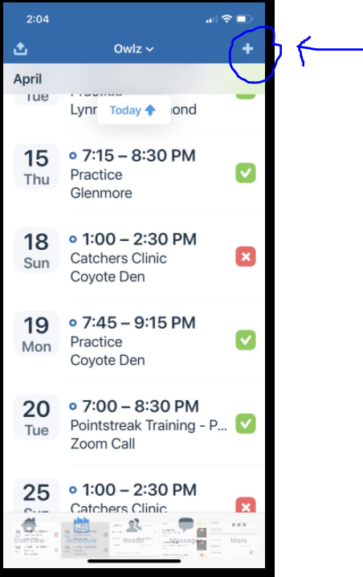

Select if you wish to add a game or an event. Practices would be considered an “event”. When you choose to add a game it gives you some different functions later – like being able to add in the final score of the game once played.

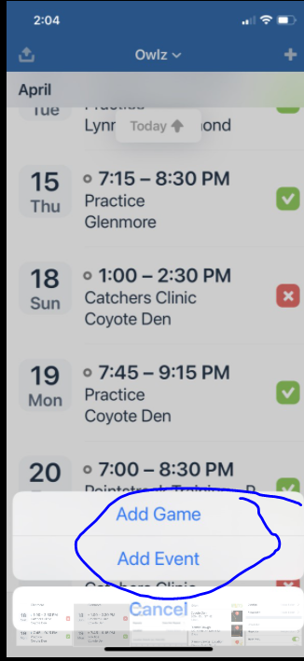

Once you are in the game or the event to create, it is pretty easy to follow all that it shows you.

When you add a game it will let you choose the opponent you are playing.

When creating an event – just give it a name…ie: Practice, Pointstreak Training, Catchers Clinic, etc

Select the time and the location.

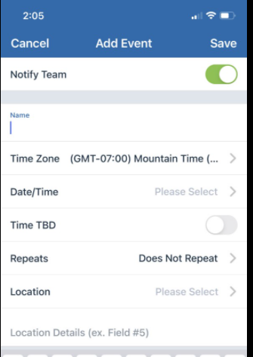

Locations have already been populated for you. Just select the one you need. IF for some reason the location you need is not listed, you can click on the “+” to add new location and it walks you through the rest.

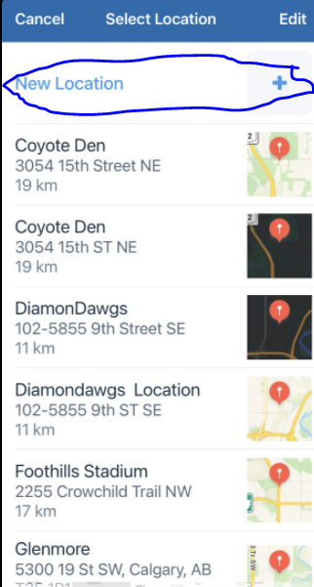

The final steps of setting up the game or the event are:

Arrive Early:

1. For practices everyone should arrive 5-10 mins in advance.
2. For Games – players must arrive 90 minutes (1 hour and 30 mins) before the game is to begin. This allows proper warm up for the game. Parents were not permitted to arrive at the game until 15 mins before the game last year due to COVID. We will update you if there is any restrictions on parents arriving.

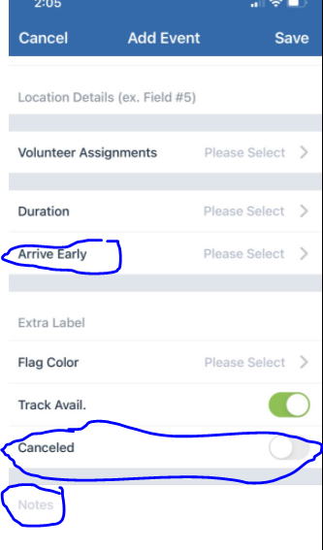

Cancellations of Games – once a game has been created and you need to cancel it – you can just click on the event and edit it and then click cancel.

The wonderful thing with TeamSnap is it automatically sends out reminders to the team via email on the scheduled events. You don’t need to do any reminders for those.